Key points for students
You will be provided with pre-populated spreadsheets to complete the tasks for this unit.

Drop-down lists
Drop-down lists can be created to limit the values that a user can enter.
The words to appear in the list need to be added to the spreadsheet first in a column.
If they will be used in a VLOOKUP they must be sorted into alphabetical order.
To create a list, click in the cell where the list should appear, then go to Data – Data validation and select ‘List from a range’ and then click in the box to the right to select the cells containing the data to appear in the list.
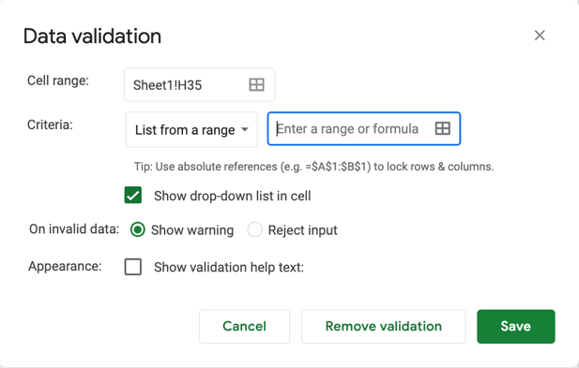

VLOOKUP function
This is a very useful function that can be used to find other information from a spreadsheet, for example looking up a student’s mark to find out what grade they have achieved.
This function requires three pieces of information:
- The cell reference for the value you wish to search for.
- The range of cells containing all the values and associated data. Remember, this will need to be set as an absolute cell reference using $ if the function is to be replicated.
- The column number of the range that contains the value to be returned and displayed. This is referred to as the index.

Sorting data
Remember to select all the data required.
Select one or more columns to be sorted and if necessary, adjust whether it should be sorted in ascending or descending order.
If your data has headings these can be used to help select the correct columns.

Check boxes
Check boxes are another way of keeping data in a spreadsheet accurate by requiring the user to select one or more options from those available.
Click on the cell requiring a check box and add it from the insert menu. The Boolean value of the check box (True or False) will be stored in the cell where the check box appears.

Macros
Macros can be created to automate certain processes in a spreadsheet.
Macros are found in the extension tab.
Make sure that the actions to be performed while the macro is recorded are planned carefully in advance.
When saving the macro, make sure that the macro name chosen does not contain any spaces.
Remember to use the drawing option from the insert tab to create a ‘button’ to assign the macro to in order to use it. Select the ‘button’, click on the three dots and then choose ‘Assign a script’ and type in the name of your macro.
Click on ‘Apps Script’ to access the JavaScript code to view or edit it. Remember to save any changes.

Logical operators
AND and OR can be used within IF functions to check for two or more conditions.

REPT function
This function is used to repeat a string of characters a given number of times. It can be used to give a visual representation of a value.

